2100031886

KATARU SHANMUKHA SAI

**CLOUD & SERVERLESS COMPUTING PROJECT**

**TITLE: LEAVE MANAGEMENT SYSTEM**

**Step1: Create a IAM Role and add policy**

**Now create a identies in Amazon SES like below**

**Create a DynamoDB named ”leavemanagement”**

**Store the data in list format.**

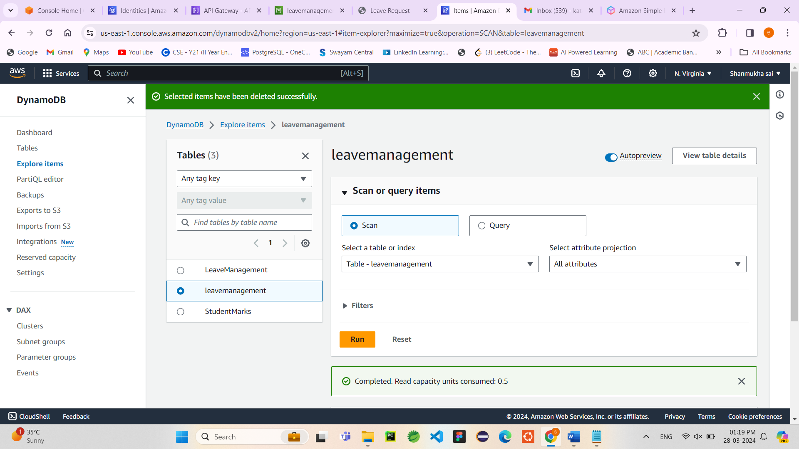

**Now create a two lambda functions**

1. **Leave management**
2. **Find leave**

**Connect the lambda with the Amazon Api Gateway use method post for it**

**Now create a another lambda named “findleave”**

**Create an another Api GateWay of method Get**

**Make URL query string parameters as Email**

**In integration request add mapping template**

**Now Trigger the API gateway with this lambda named “findleave”**

**Now create a s3 Bucket**

**Name : “leavemanagementsystem”**

**Enable static website hosting in properties**

**Add bucket policy in permissions**

**Upload the files in s3 bucket**

[about.html](https://s3.console.aws.amazon.com/s3/object/leavemanagementsystem?region=us-east-1&bucketType=general&prefix=about.html) **,** [apply_leave.html](https://s3.console.aws.amazon.com/s3/object/leavemanagementsystem?region=us-east-1&bucketType=general&prefix=apply_leave.html), [Home1.html](https://s3.console.aws.amazon.com/s3/object/leavemanagementsystem?region=us-east-1&bucketType=general&prefix=Home1.html), [jquery-3.1.1.min.js](https://s3.console.aws.amazon.com/s3/object/leavemanagementsystem?region=us-east-1&bucketType=general&prefix=jquery-3.1.1.min.js), [knockout-3.4.2.js](https://s3.console.aws.amazon.com/s3/object/leavemanagementsystem?region=us-east-1&bucketType=general&prefix=knockout-3.4.2.js), [search_leaves.html](https://s3.console.aws.amazon.com/s3/object/leavemanagementsystem?region=us-east-1&bucketType=general&prefix=search_leaves.html)

**For html pages invoke the url from API GateWay to store the data in dynamodb and retrieve the data form it**

**OutPut :**

**Now we will get the mail.**

**I wrote a lambda code like if leaves>n then the mail will reject**

**Data stored in DynamoDb:**

**Now we are searching for number leaves applied by the person**

